Learner’s Academy

Software Requirements Specification

1.0

11-03-2023

Roseline Ayitey

Lead developer

Prepared for

Simplilearn FSD Programme

## Introduction

Learner’s Academy is a school that has an online management system. The system keeps track of its classes, subjects, students, and teachers. It has a back-office application with a single administrator login. This document provides details on product’s capabilities, appearance, user interactions.

## Purpose

The purpose of this document is to capture the product details below.

* Product’s capabilities, appearance, and user interactions
* Project and developer details
* Sprints planned and the tasks achieved in them
* Algorithms and flowcharts of the application
* Core concepts used in the project
* Links to the GitHub repository to verify the project completion

## Product Capabilities

The product is a backend administrative portal for a school management system that provides the options to administrators to perform the below activities

* Set up a master list of all the subjects for all the classes
* Set up a master list of all the teachers
* Set up a master list of all the classes
* Assign classes for subjects from the master list
* Assign teachers to a class for a subject
* Get a master list of students
* View Class Report which will show all the information about the class, such as the list of students, subjects, and teachers

**Process Flowchart**

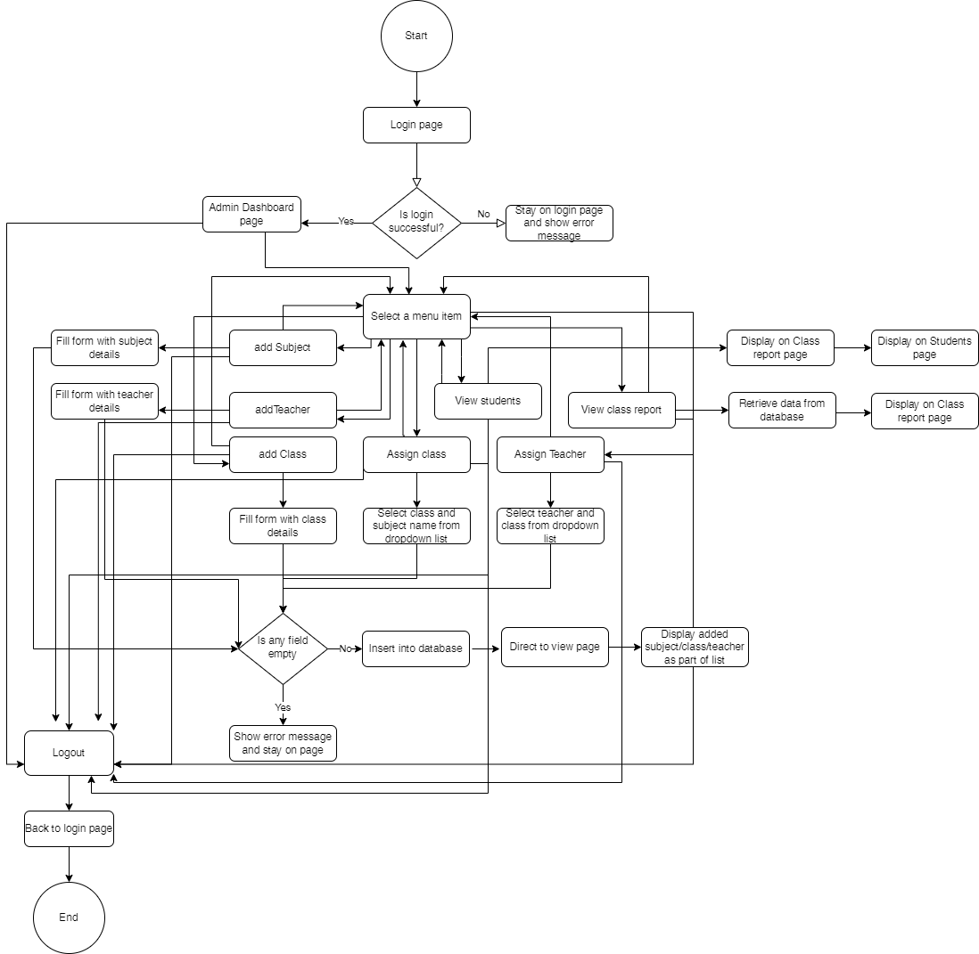

### User Interfaces

**GUI**  
As this is a web application, user interaction is via GUI.

**APPLICATION FLOW**

Step1 - Application starts by displaying the login page for the administrator to login in

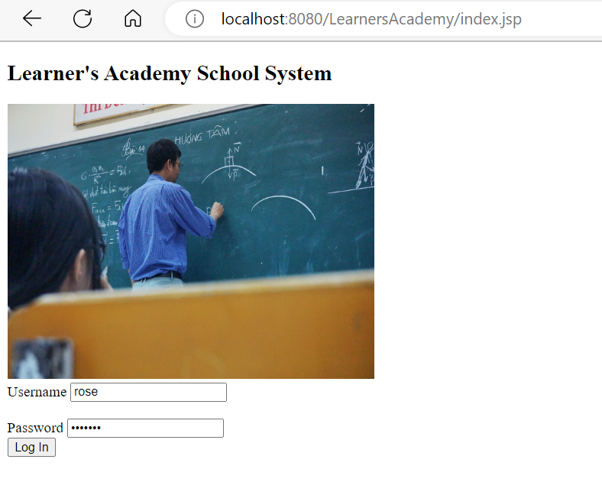

Step 2: Take user input and check if credentials are correct. Stay on login page and show error message if credentials are not correct.

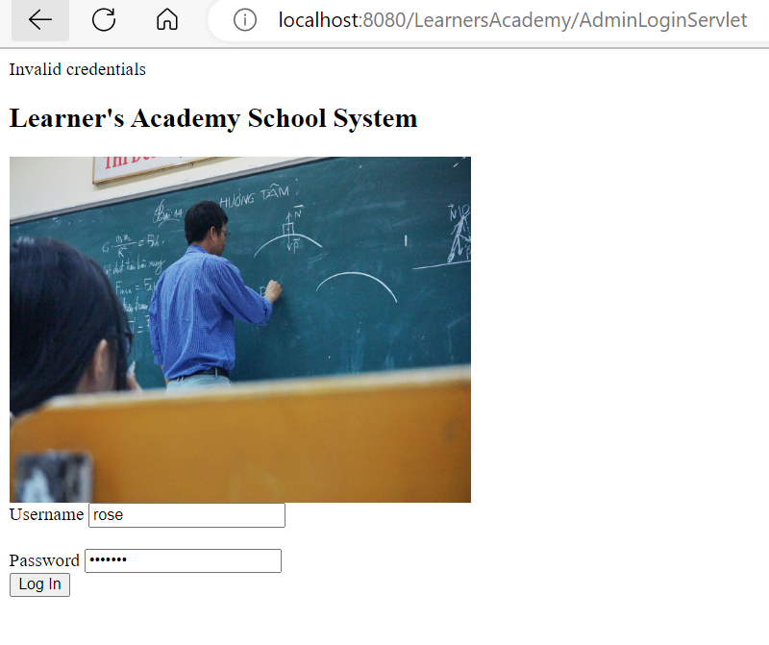

Step3. Display dashboard page with menu items if credentials are correct

|  |
| --- |
|  |

Step 4 – Select an item from the menu options

1. Set up a master list of all the subjects for all the classes. Admin can add a new subject to the master list.

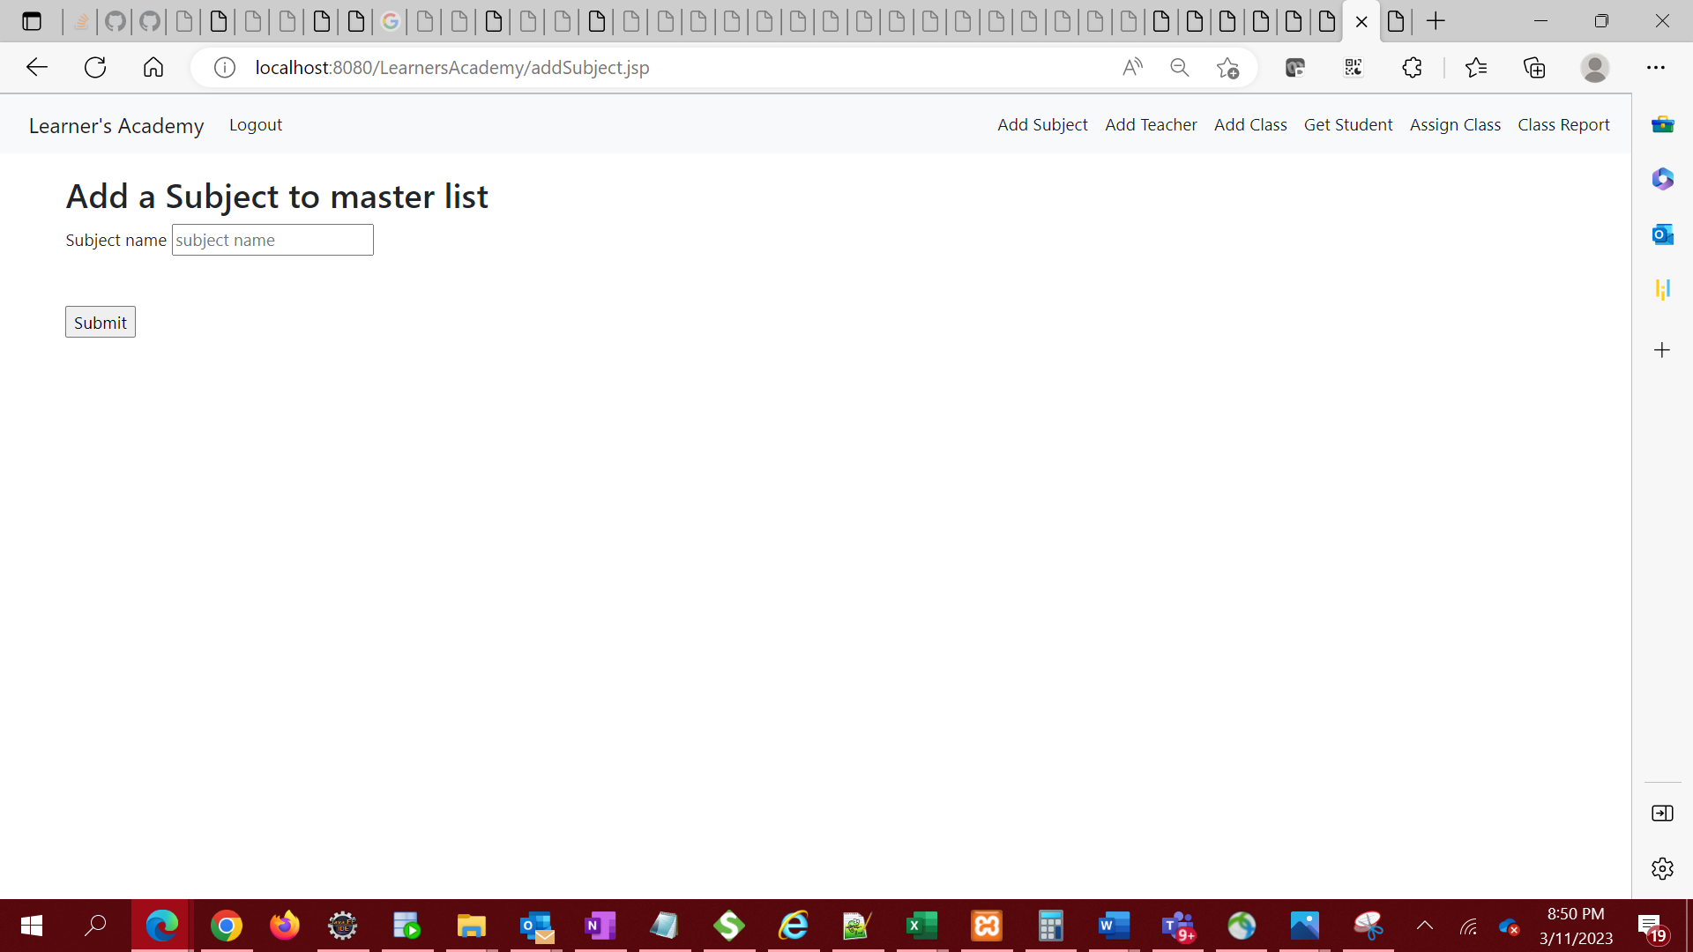

i. Validate input to ensure field is not empty on submission. If input is empty, stay on same page and display error message in url.

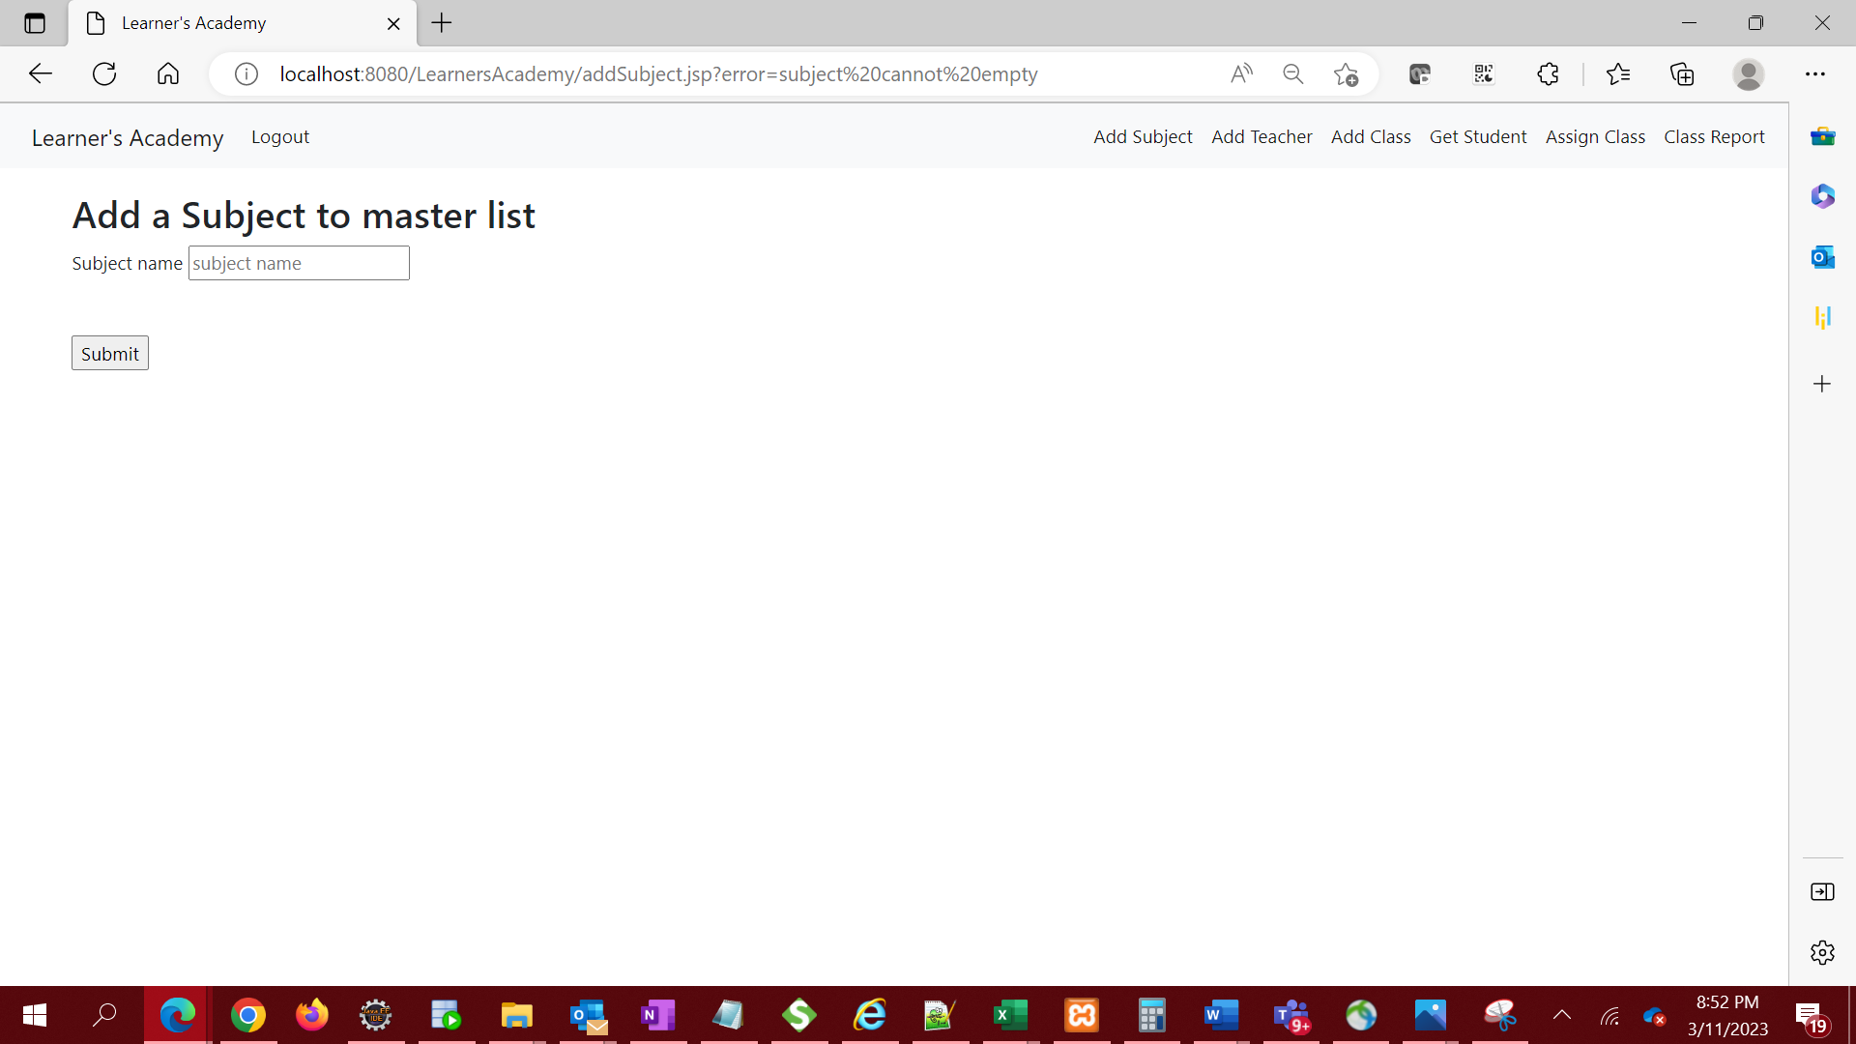

ii. If input is not empty, submit to database and redirect to subjects page to view the subject added

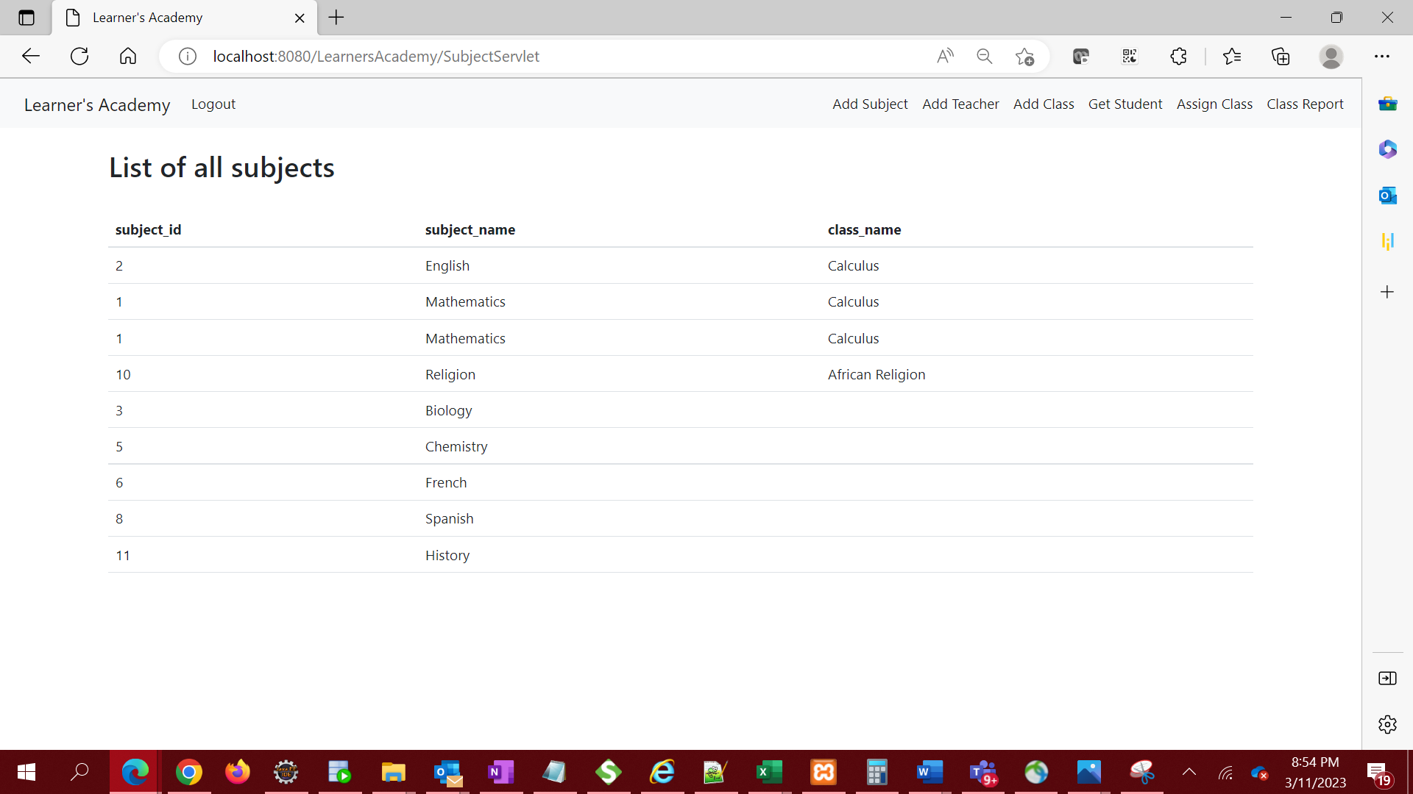

1. Set up a master list of all the teachers

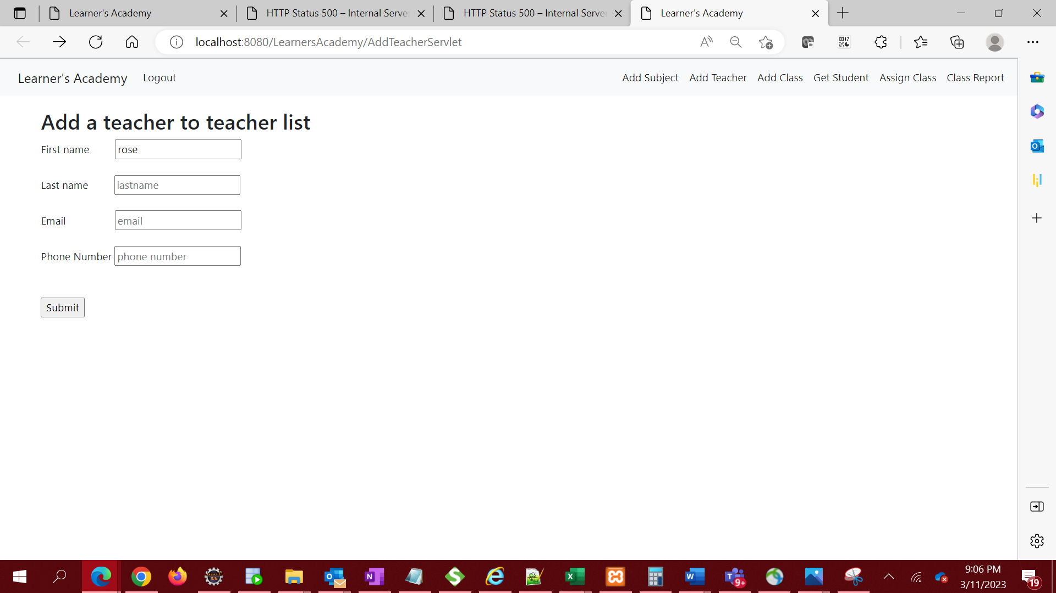

i. Validate input to ensure field is not empty on submission. If input is empty, stay on same page and display error message in url.

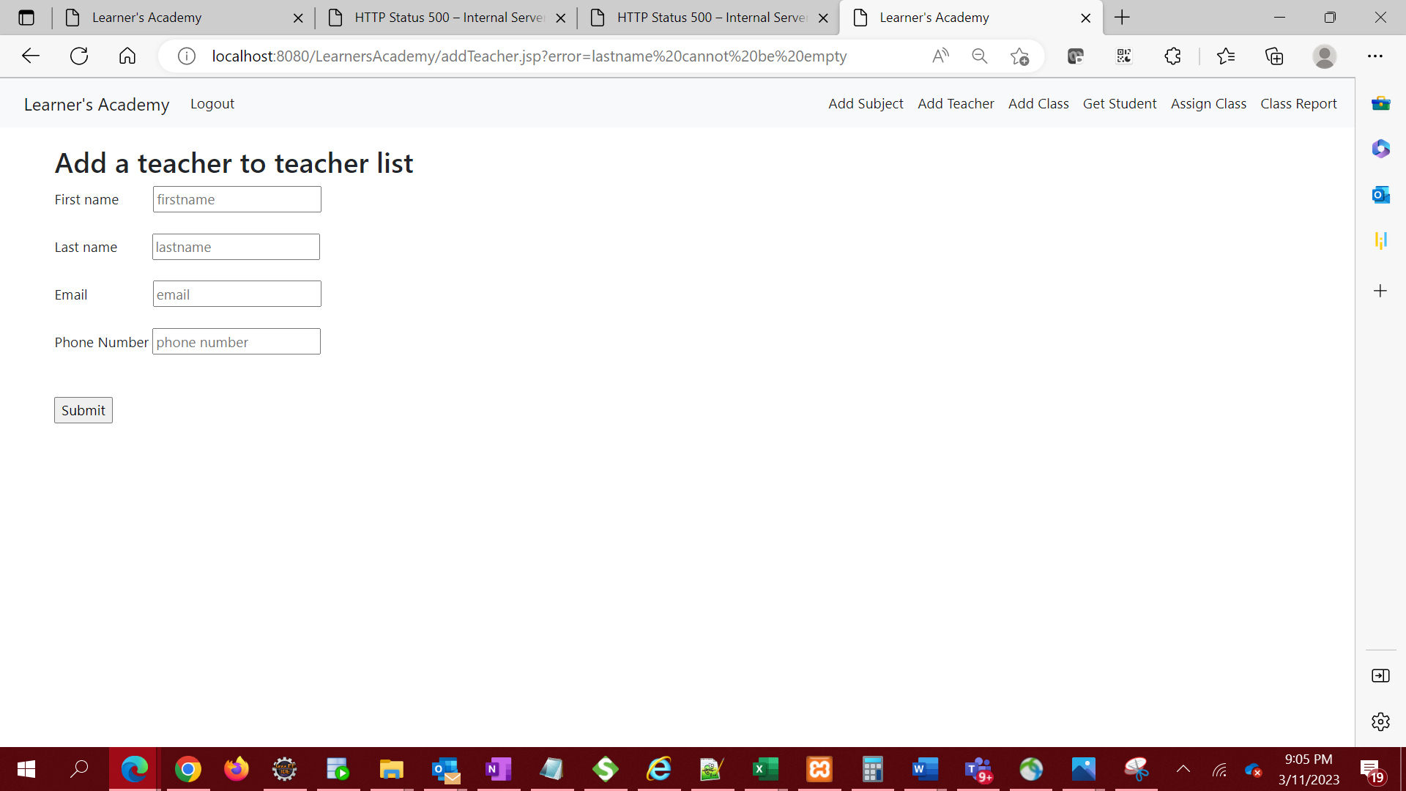

ii. If input is not empty, submit to database and redirect to View teacher’s page to view the teacher added.

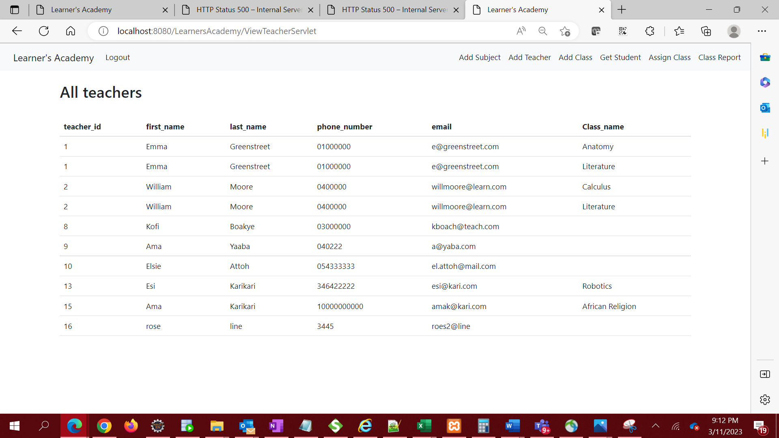

1. Set up a master list of all the classes

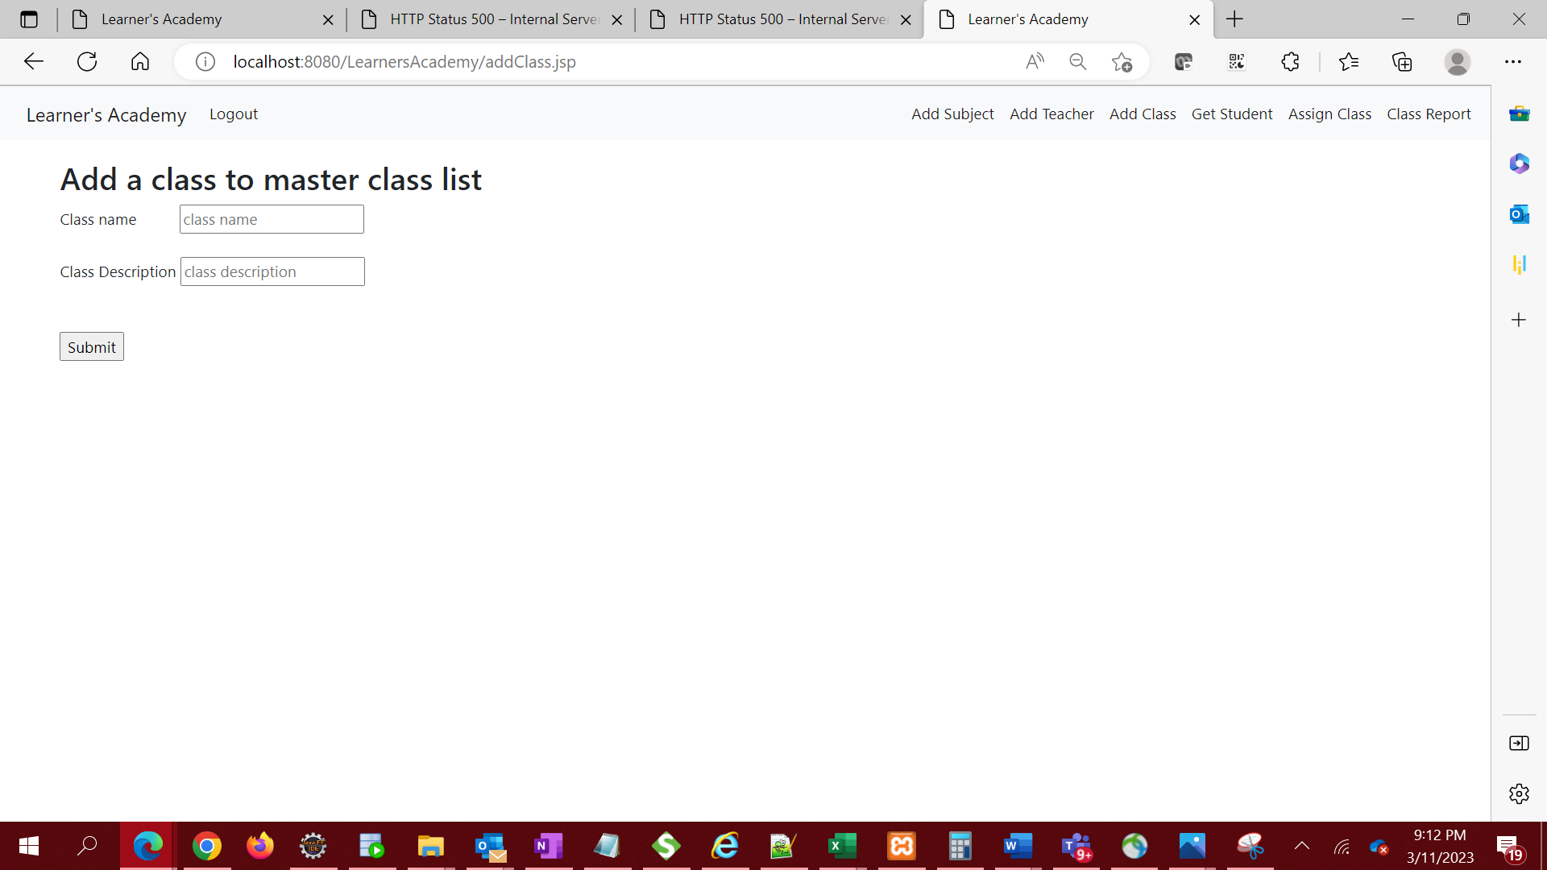

1. Validate input to ensure field is not empty on submission. If input is empty, stay on same page and display error message in url.

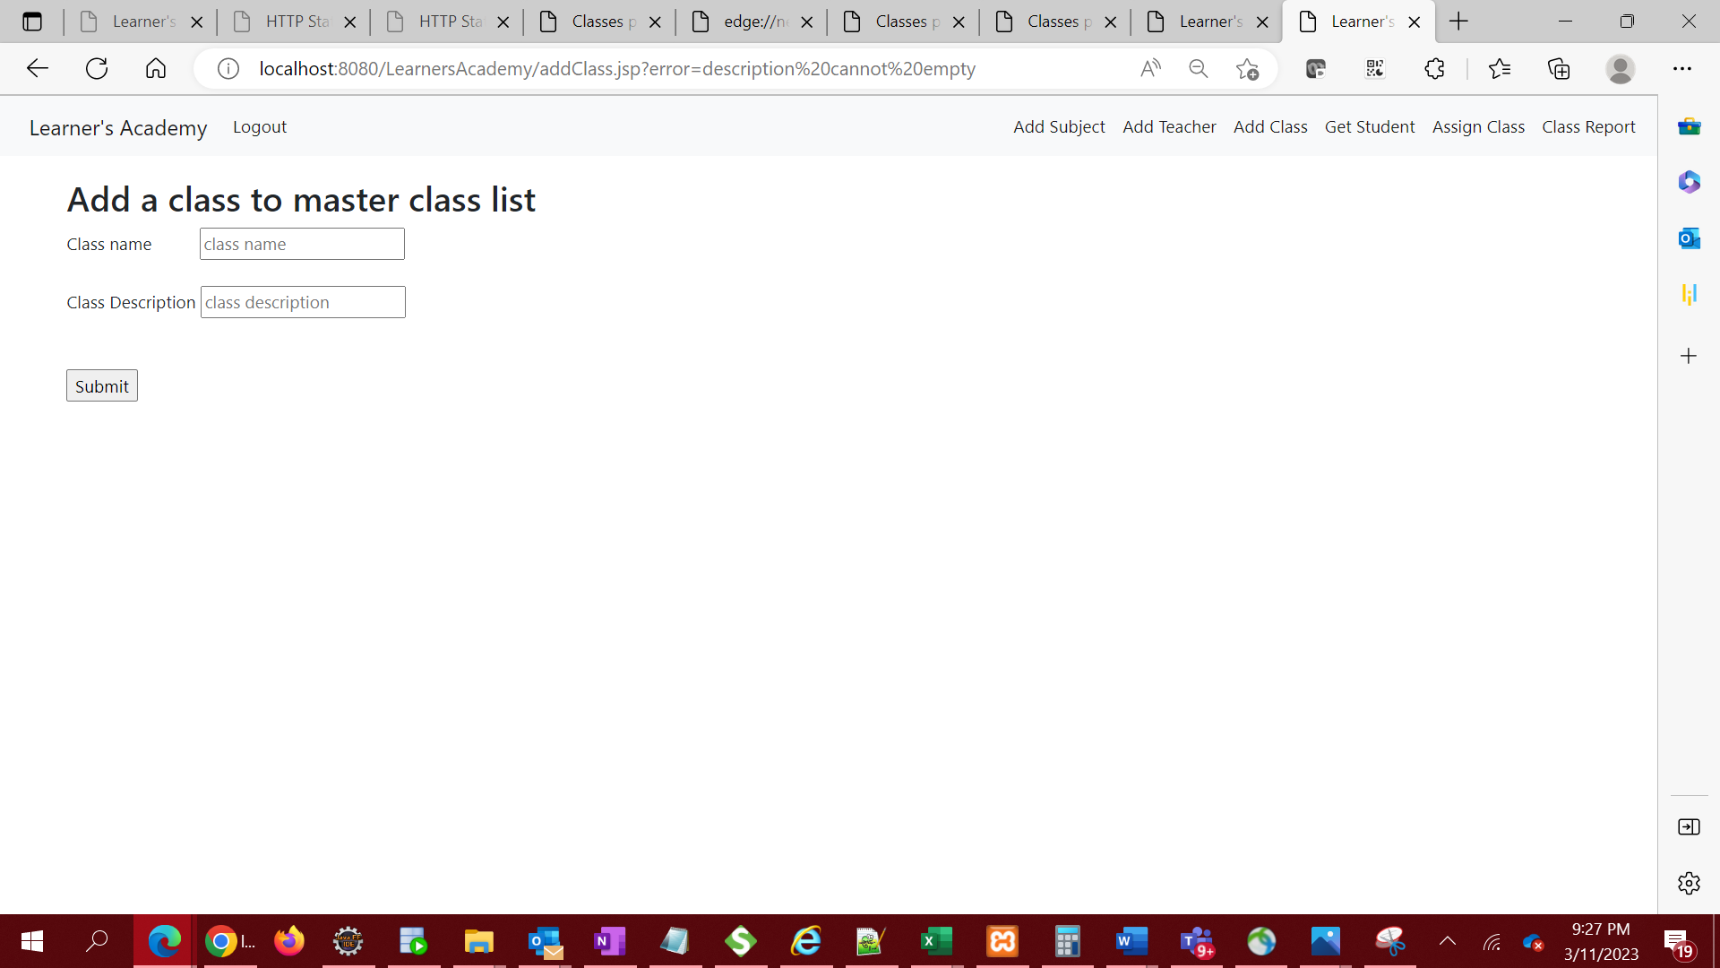

1. If input is not empty, submit to database and redirect to View Class page to view the class added.

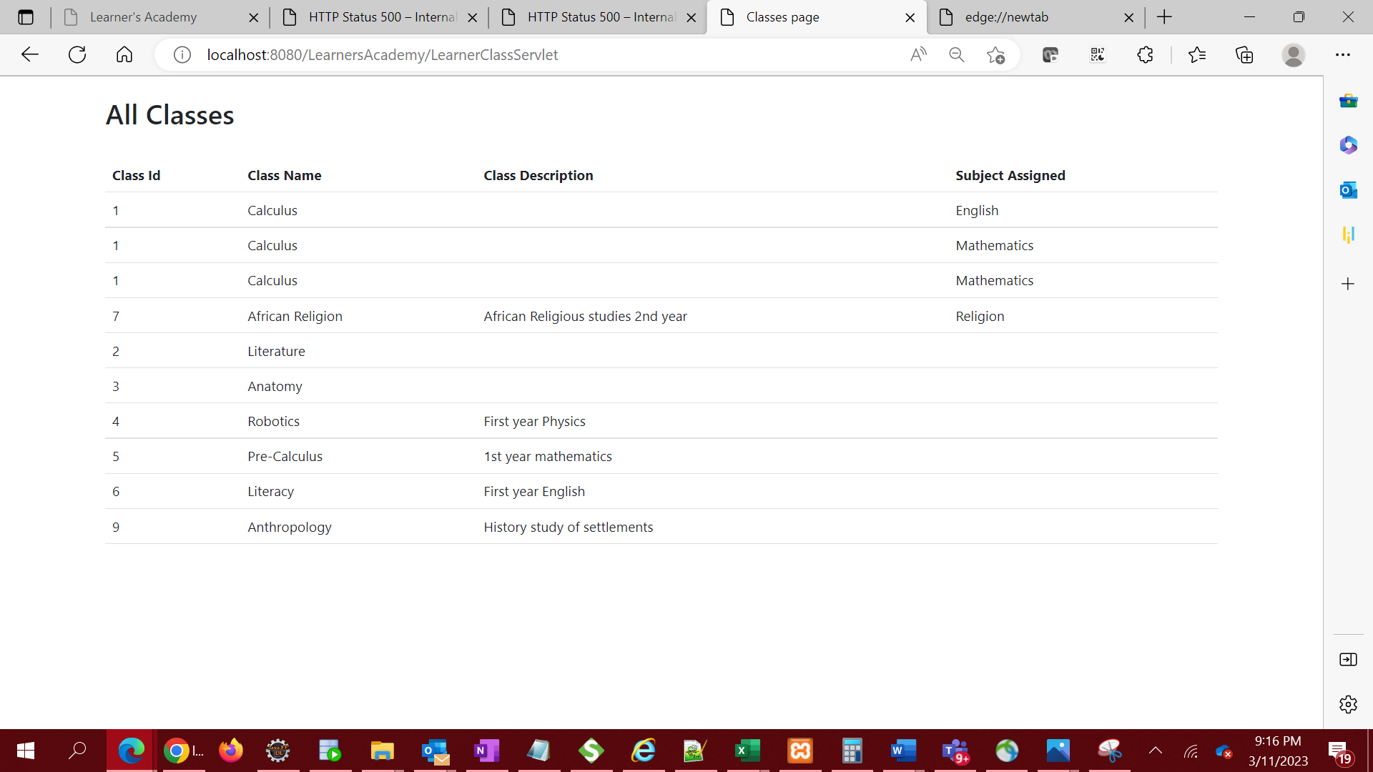

1. Assign classes for subjects from the master list

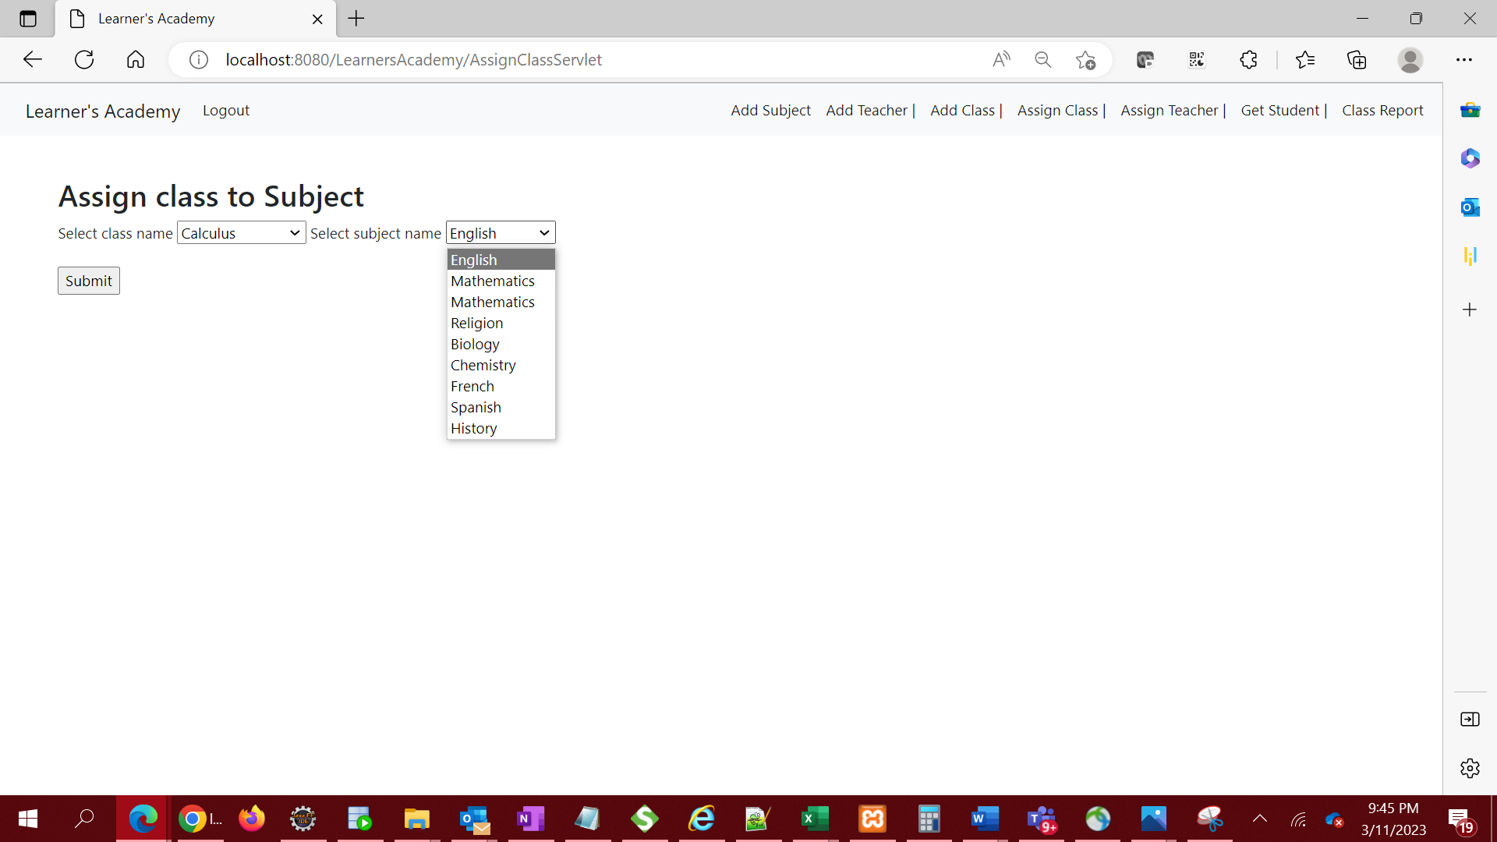

1. submit to database and redirect to All Class page to view the class subject assigned.

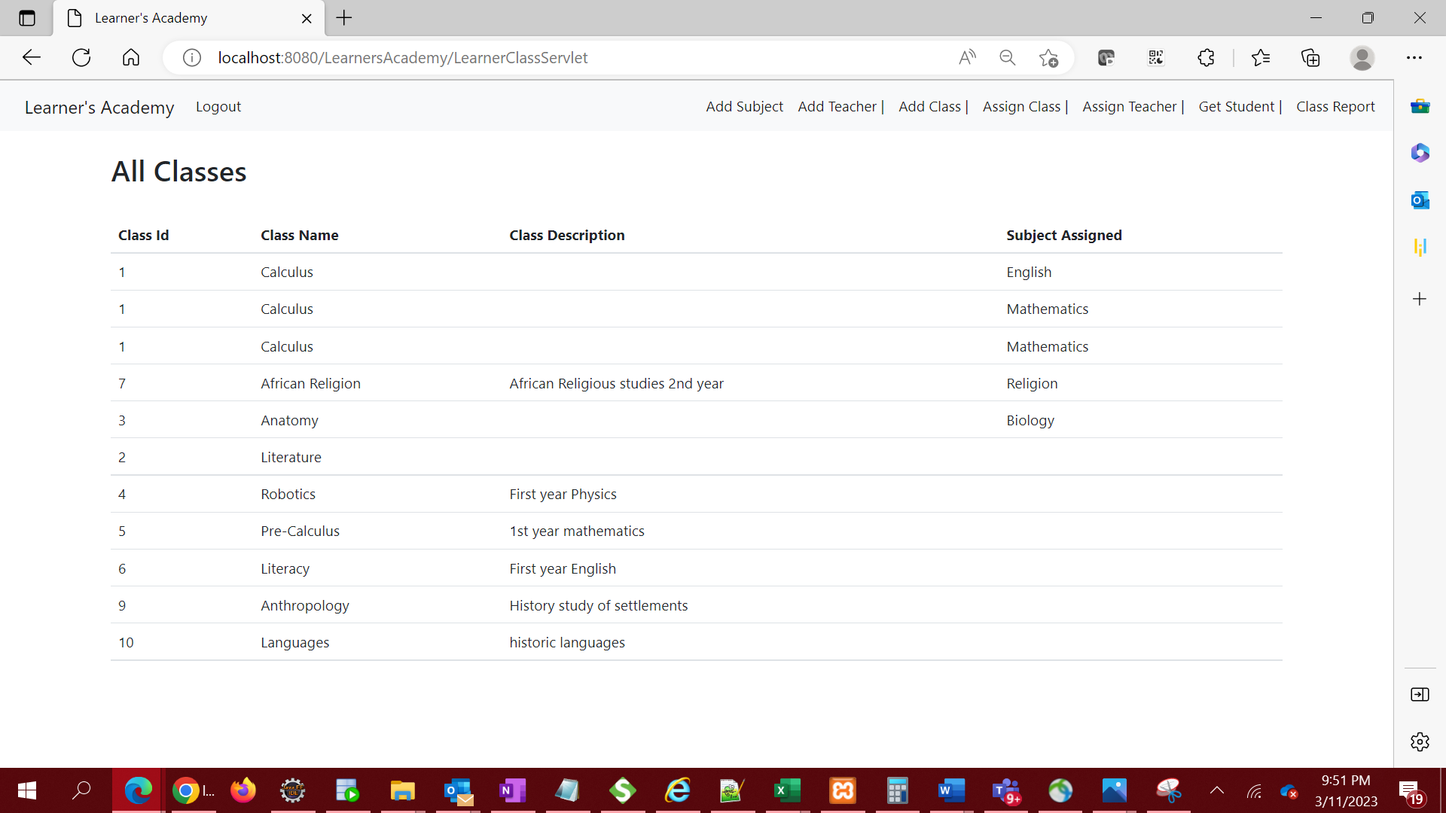

1. Assign teachers to a class for a subject

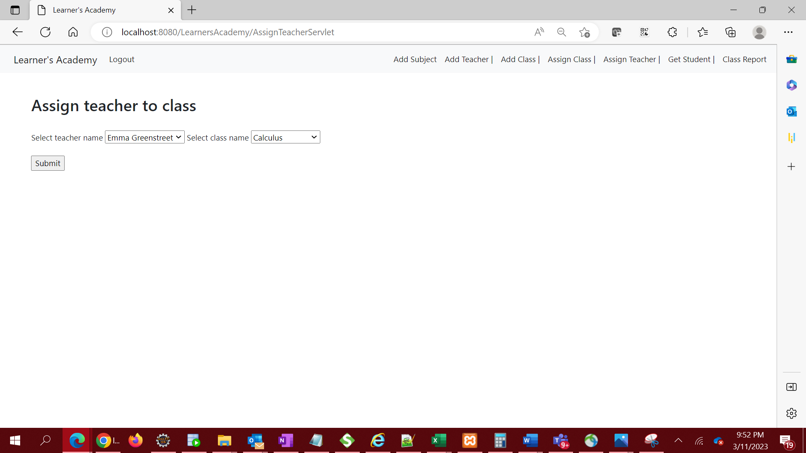

1. submit to database and redirect to All teachers page to view the teacher and class assigned.

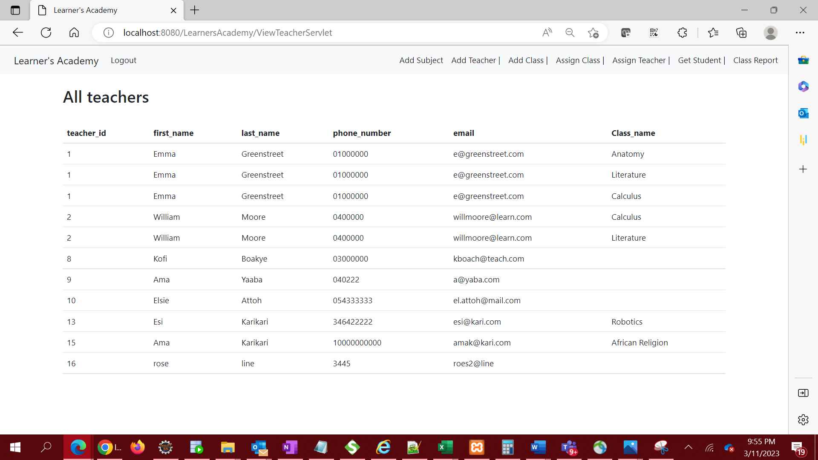

1. Get a master list of students – Fetch student list from database and display on All Students page

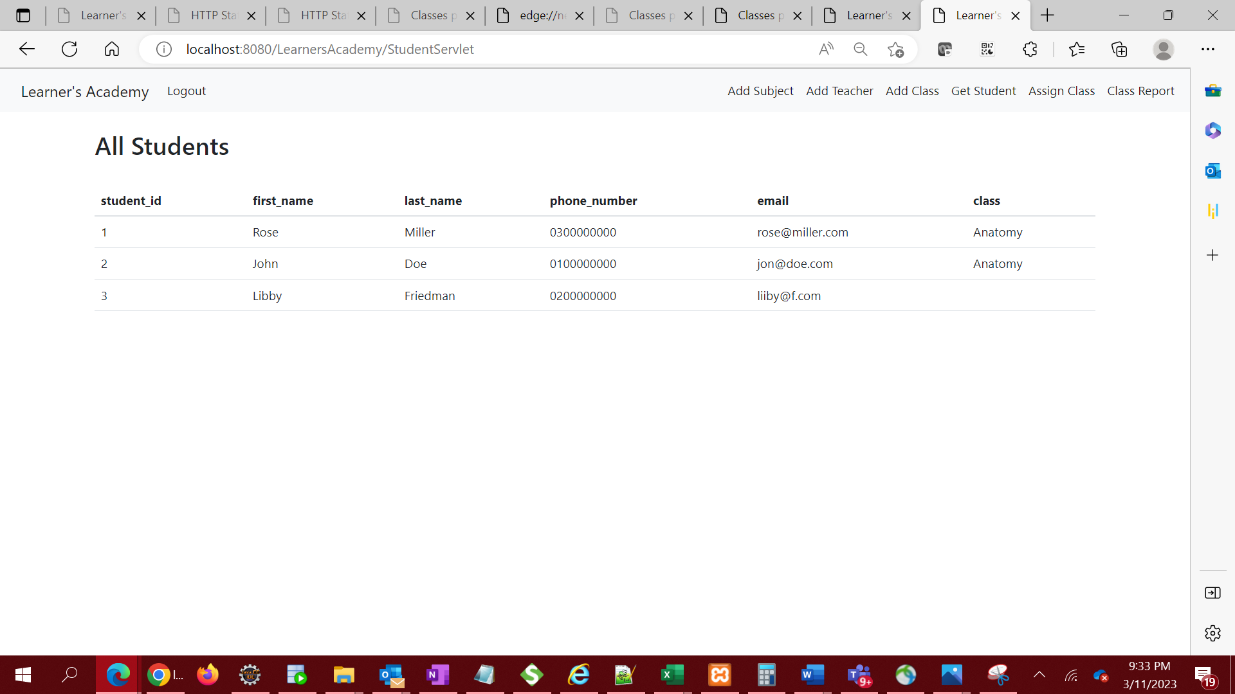

1. View Class Report show all the information about all the class, such as the list of students, subjects, and teachers

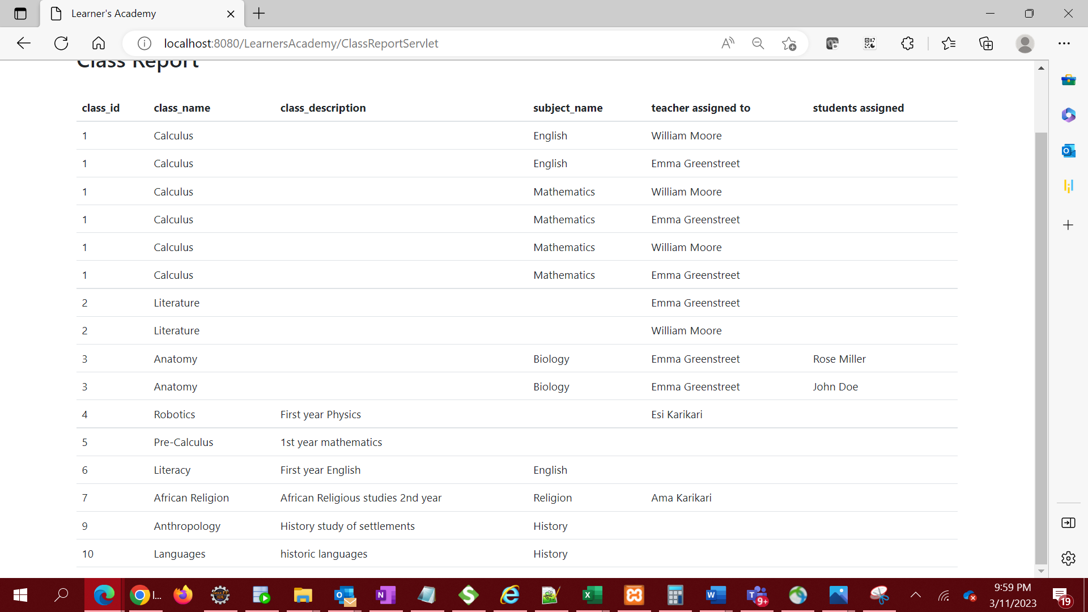

1. Logout of the application.

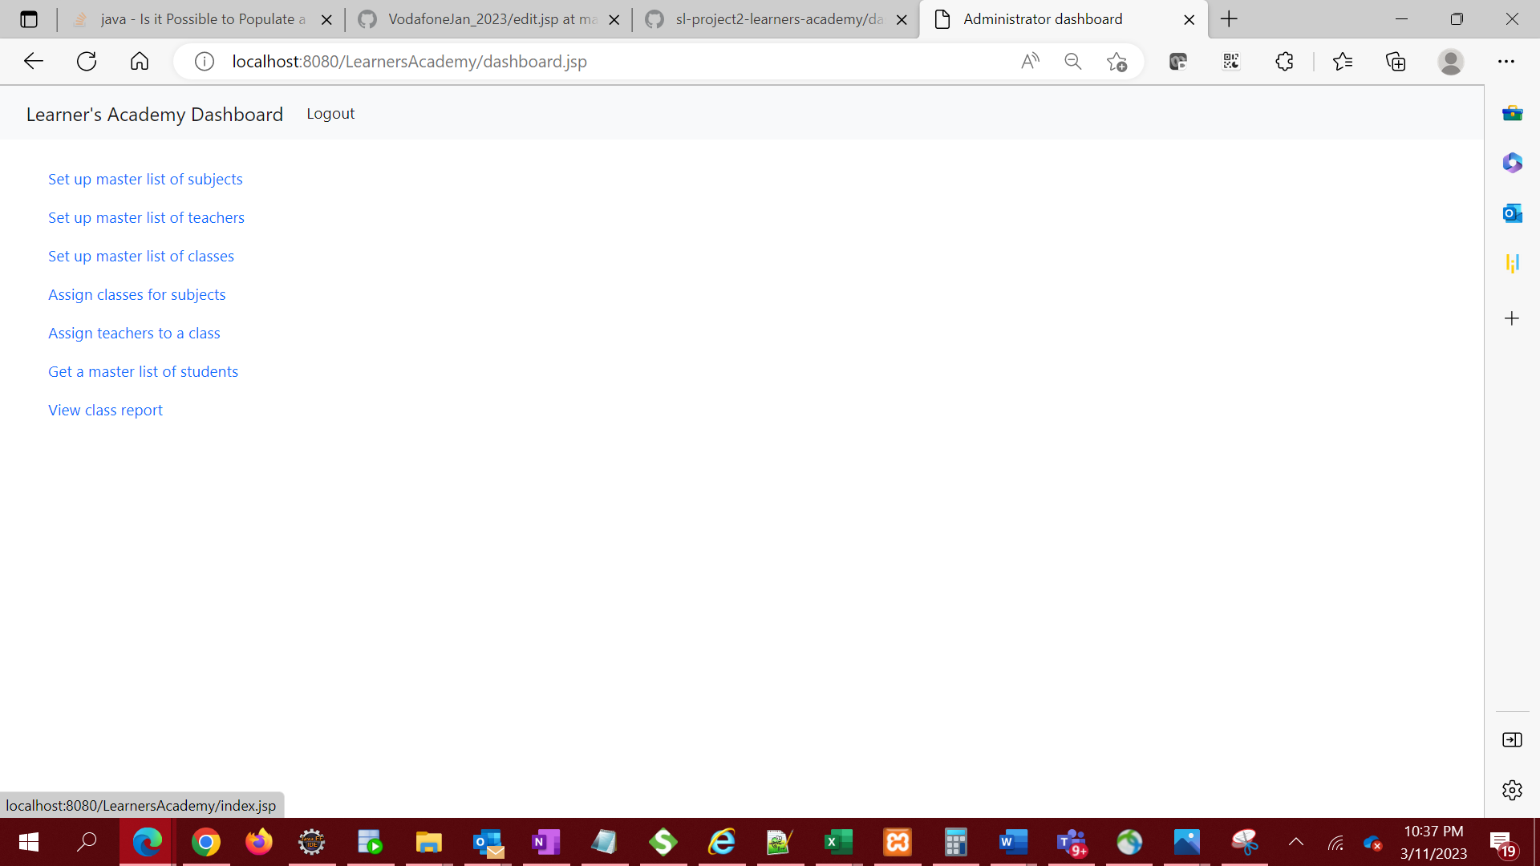

1. Logout of the application takes administrator back to the login page.

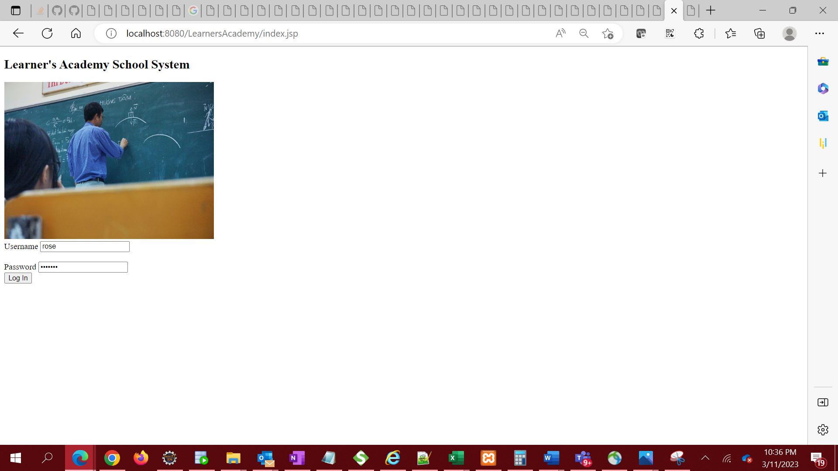

**SPRINT PLANNING**

The functionalities were converted to below user stories with story points assigned and placed in the product backlog. LA – (Learners Academy)

|  |  |  |
| --- | --- | --- |
| Story ID | User Story (Product backlog) | Story points |
| LA01 | As an administrator, I want to set up a master list of all the subjects for all the classes so that I can add subjects. | 5 |
| LA02 | As an administrator, I want to set up a master list of all the teachers so that I can add teachers | 5 |
| LA03 | As an administrator, I want to set up a master list of all the classes so that I can add classes | 5 |
| LA04 | As an administrator, I want to assign classes for subjects from the master list | 8 |
| LA05 | As an administrator, I want to assign teachers to a class for a subject | 8 |
| LA06 | As an administrator, I want to get a master list of students so that I can view all students | 3 |
| LA07 | As an administrator, I want to view a Class Report which will show all the information about the class, such as the list of students, subjects, and teachers | 3 |
| LM08 | As an administrator, I want to exit the application when I am done with my operations. | ~~1~~ |
| LM09 | As an administrator, I want to login to the application to perform my operations | ~~3~~ |

**The application was completed in 3 sprints with breakdown below.**

Sprint 1 || Stories - LA01, LA05, LA09 || Total points – 16

Sprint 2 || Stories LA02, LA04, LA06 || Total points – 16

Sprint 3 || Stories LA03, LA07, LA08 || Total points – 14

**CORE CONCEPTS AND ALGORITHYMS USED**

* JSP
* Servlets
* SQL
* JDBC
* CSS

Link to the GitHub repository

https://github.com/roselinemills/LearnersAcademy

**CONCLUSION**

The project is designed to be intuitive, easy to use and deliver high-end quality experience to the client.